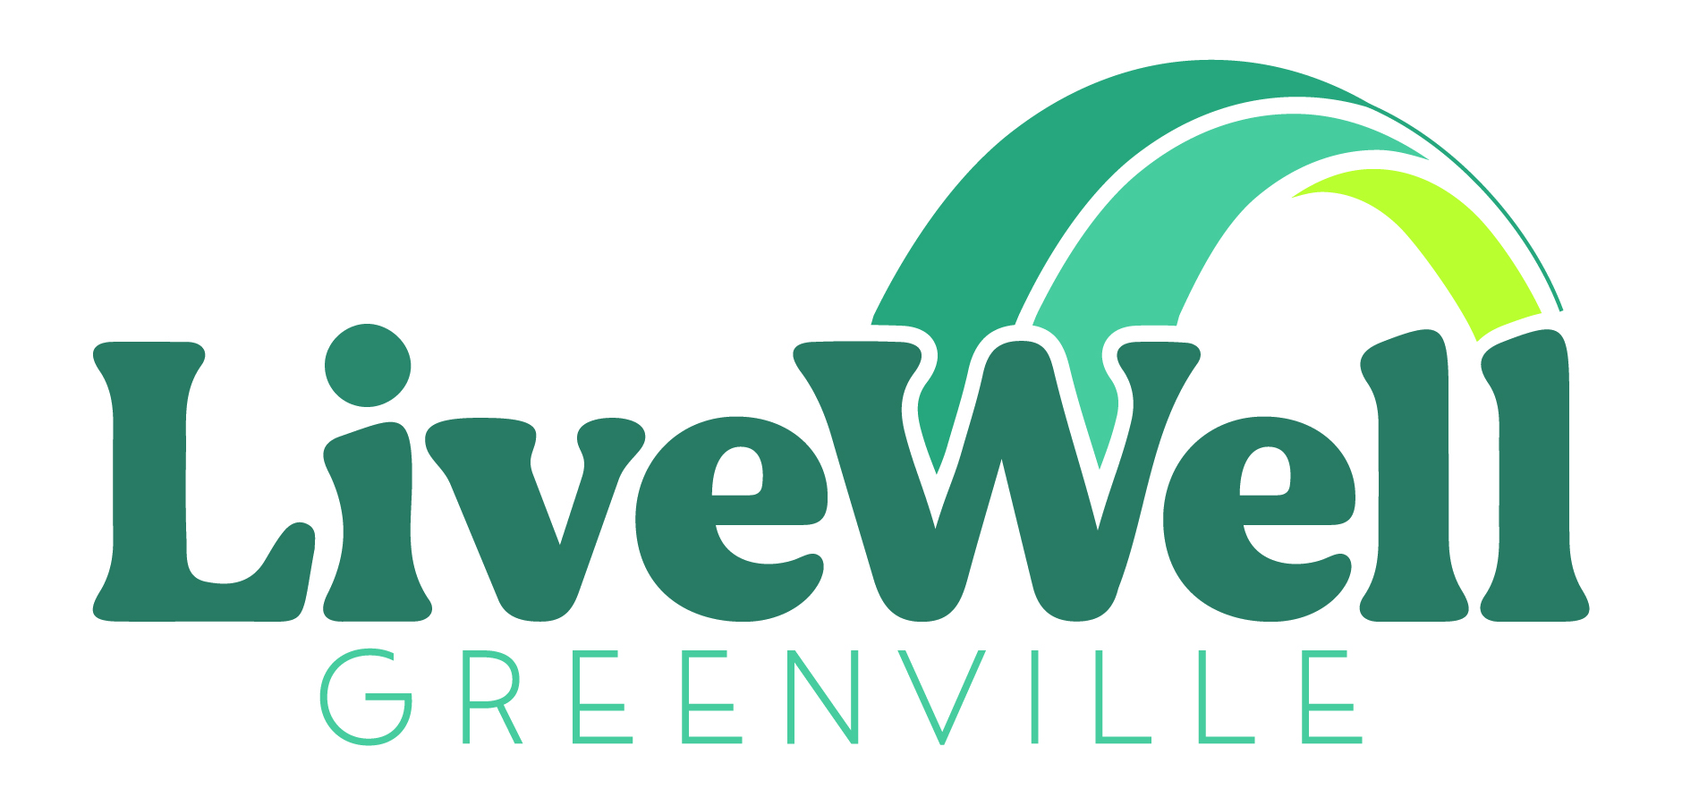
POLICY AND ADVOCACY DIRECTOR
LiveWell Greenville
www.LiveWellGreenville.org

ABOUT LIVEWELL GREENVILLE:
LiveWell Greenville is a coalition that has been addressing childhood obesity in Greenville County for over 10 years. Our coalition has more than 200 community partners focused on changing the systems and environments that prevent equitable access to healthy foods and physical activity opportunities.
ABOUT GREENVILLE COUNTY EQUITY IN PUBLIC HEALTH INITIATIVE:
Funded by the Office of Minority Health and the Office of the Assistant Secretary for Health in the Department of Health and Human Services, the primary goal of the Equity in Public Health (EPH) initiative is to improve the health of Black and Hispanic community members living in Greenville County, SC, by addressing local and state policies and practices that contribute to structural racism and perpetuate health inequities by race and ethnicity. Three community-based coalitions and two universities are collaborating to form the EPH team: LiveWell Greenville, Hispanic Alliance, the Racial Equity and Economic Mobility (REEM) Commission of Greenville, Clemson University’s Departments of Political Science and Public Health, and Furman University’s Institute for the Advancement of Community Health and Department of Health Sciences. Documented health disparities exist in Greenville County, and at the conclusion of this three-year initiative, the EPH team expects to change conditions that will support better health outcomes for Black and Hispanic community members.
POSITION SUMMARY:
LiveWell Greenville seeks a Policy and Advocacy Director to shape the EPH Team’s policy agenda, facilitate the development of a community action plan, and provide leadership and direction to Policy Directors at Hispanic Alliance and REEM Greenville. The Director will work with the Policy Assessment Research Team to complete the Policy Assessment, and will utilize the results of the assessment to oversee the creation of the policy agenda that will guide the EPH Team’s work. The Director will mobilize community partners across coalitions and the multi-stakeholder Community Action Board to educate and guide action regarding policy changes to combat structural racism in public health.
PRIMARY RESPONSIBILITIES:
- Build relationships. Engage with elected officials, community members, organizational leaders and others that can be mobilized to advocate for needed changes to address the root causes of structural racism in public health and health inequities in Greenville County. This will include regularly attending local council meetings, engaging in advocacy efforts at the state house/senate, and meeting and building coalition with local community members
- Lead LiveWell Greenville advocacy efforts including overseeing the development and action steps towards achieving LiveWell’s policy agenda
- Support the EPH Team in convening the Community Action Board and building the Community Action Plan
- Coordinate and facilitate EPH Partner meetings to ensure the development of a policy and advocacy action plan
- Engage with the EPH Leadership and Research/Evaluation Teams to support the completion of the policy and practice assessment
- Develop advocacy plan and material for educating state and government stakeholders
- Collaborate with other advocacy organizations to build community power, voice and engagement to shift organizational, local, state and national policies
- Actively engage with members of the LiveWell Greenville team to develop plans to mobilize community efforts to address needed policy changes
- Develop and implement curriculum and training plan for community education sessions on structural racism in perpetuating health inequities

QUALIFICATIONS AND EXPERIENCE:
It is ok if you do not meet every qualification! Don’t let that stop you from applying if you believe that you have the skills to help us advance LiveWell Greenville’s mission.
The internal culture of LiveWell Greenville and the EPH Leadership Team is highly collaborative and requires a strong commitment of personal responsibility in achieving work goals. Our diverse team brings a wealth of lived experiences, perspectives, and skills to our work and share a passion for social change and equity. The ideal candidate for this position is an inclusive, adaptive, and strategic leader able to build trusting relationships and create consensus across differing viewpoints.
- Bachelor’s Degree in Public Policy, Political Science, or Public Health preferred; however, key understanding of civics, the political process and political science is the most crucial requirement of the position
- Experience with public policy, advocacy, or in state/federal government
- Familiarity with South Carolina government systems and issues
- Experience leading or coordinating multi-organizational consensus building, common agenda, or other broad stakeholder initiative
- Expertise in understanding interpersonal dynamics, relationship building and consensus building. Ability to work collaboratively with diverse groups and demonstrated commitment to social change work
- Strong leadership, negotiation, communication, listening, and influencing skills
- Fluency in both English and Spanish
- Positive, proactive and personable team player
- Ability to work independently and as part of a collaborative team.
- Ability to work remotely or in an office setting as needed. Currently team members are required to be in the office every Wednesday and the number of in office/collaboration days could increase in the future
- Requires flexibility and some travel
JOB CLASSIFICATION:
Full time (37.5 hr/week). This is a three-year position with possibility of extension.
Expected Salary: $65,000 annually depending on experience.
Apply Now!
Please, no phone inquiries.

