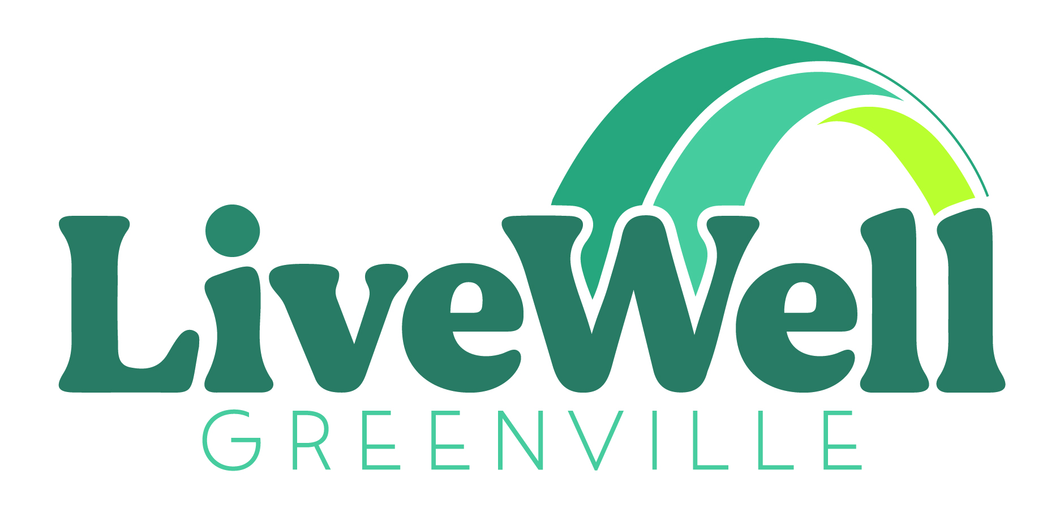
FUND DEVELOPMENT DIRECTOR
LiveWell Greenville
www.LiveWellGreenville.org

ABOUT LIVEWELL GREENVILLE:
LiveWell Greenville is a coalition that has been addressing childhood obesity in Greenville County for over 10 years. Our coalition has more than 200 community partners focused on changing the systems and environments that prevent equitable access to healthy foods and physical activity opportunities.
POSITION SUMMARY:
LiveWell Greenville seeks a Fund Development Director to provide financial leadership and guidance to the coalition. As a collective impact organization, LiveWell Greenville’s fiscal support comes predominantly from grants and partner contributions. The Director will create and manage funding strategies including sponsorships, contributions, businesses and foundations, to support the coalition’s budget and work.
PRIMARY RESPONSIBILITIES:
- Design and implement a comprehensive coalition fund development strategy that diversifies LiveWell Greenville’s funding streams outside of grants
- Build relationships with partner organizations to maintain and increase contributions to support LiveWell Greenville’s work
- Work as part of a team to support grant submission to meet the needs of the coalition initiatives
- Seek sponsorship for coalition events and create new events to raise funds to support the coalition
- Work collaboratively with the Executive Director and the finance committee (board committee) to develop the annual budget and build strategies to meet income goals
- Coordinate with Communications Director to oversee external communications strategy to increase coalition awareness and investment
- Make presentations to potential partners, community groups and individuals

QUALIFICATIONS AND EXPERIENCE:
It is ok if you do not meet every qualification! Don’t let that stop you from applying if you believe that you have the skills to help us advance LiveWell Greenville’s mission.
The internal culture of LiveWell Greenville is highly collaborative and requires a strong commitment of personal responsibility in achieving work goals. Our diverse team brings a wealth of lived experiences, perspectives, and skills to our work and shares a passion for social change and equity. The ideal candidate for this position is an inclusive, adaptive, and strategic leader able to build trusting relationships and create consensus across differing viewpoints.
- Bachelor’s Degree required
- Experience in development or community relations with a vision for building and executing comprehensive fund development plans. The Director will have the support of the team for implementation of development efforts but this position requires an ability to both plan strategically and implement efforts.
- Expertise in understanding interpersonal dynamics, relationship building and consensus building. Ability to work collaboratively with diverse groups and demonstrated commitment to social change work
- Understanding of health equity, social justice and non-profit systems that create community change
- Strong leadership, negotiation, communication, listening, and influencing skills
- Positive, proactive and personable team player
- Ability to work independently and as part of a collaborative team
- Ability to work remotely or in an office setting as needed. Currently team members are required to be in the office every Wednesday and the number of in office/collaboration days could increase in the future
- Requires flexibility and possibility of weekend and/or evening work
JOB CLASSIFICATION:
Full time (37.5 hr/week).
Expected Salary: $65,000 annually depending on experience.
Apply Now!
Please, no phone inquiries.

